**August 4, 2017**

**Newsletter**

The Oaks

*As we had informed you via written and email communication last month, Dannie Simons is retiring. He has served our association as Business Coordinator for the past 18 months. During this time he has worked diligently to improve our property, and streamlined methods used in managing our complex. The Board is extremely grateful for his dedication. We wish him and Sue the best as they head off to have some fun times with family.*

*Mike Rohde is currently serving as Business Coordinator. He may be reached by calling The Oaks phone number (830) 265-4880 and leave a voicemail message or by email to* [*theoakscondos.hsb@gmail.com*](mailto:theoakscondos.hsb@gmail.com)

**PAINTING:**

The wood on the carports, stairways and balconies in the 300 and 400 buildings have been freshly painted. The 100 and 200 buildings are being scheduled for completion this fall.

**TREE TRIMMING:**

Most of the trees on the property have been trimmed of dead branches. We will continue as needed.

**PAVEMENT RESEAL:**

Our pavement reseal was completed in early spring. We can all agree that it sure made a difference in how nice our property looks. We have some vehicles that have significant oil leaks, causing acceleration of deterioration and unsightly stains on the pavement. As mentioned in our April 2017 Newsletter, violation notices will be forwarded to the unit owner requesting oil be immediately cleaned from the pavement. Oil leaks not cleaned within 24 hours of receipt of the notification will be cleaned by property management and a $50 pavement cleaning fee will be assessed to the owner of the unit. **Investor owners, please share this information with your** **tenants.**

**SPRINKLERS:** A major repair has been done to the sprinkler system on the east end of the 200 building. Also, a number of areas that would benefit from the installation of an additional sprinkler have been identified and will be worked into the schedule.

## Updates on projects

**The Oaks Council of Co-Owners**

# Business Coordinator

**PARKING:**

With the implementation of the parking permits procedure, and the creation of a few more parking spaces, some of our more critical parking issues have been remedied. However, it is very important that owners and tenants a like, adhere to the maximum limit of 2 vehicles per unit, with the second vehicle on a first come first serve basis in the overflow parking. We understand that we will all have visitors and guests from time to time. But in consideration of your fellow owners, please move your vehicle to the overflow parking by the clubhouse gates, if your guest is here for an extended time, allowing them to park in your covered space. Only valid Oaks Parking Permits are allowed.

**AIR CONDITIONERS:**

This summer’s hot and humid weather is causing our air conditioner units to work overtime. We advise that all owners consider having a routine annual, preventative maintenance service performed on their units, to ensure that your AC unit has proper drainage for the condensation.

Each owner has an individual web page for their convenience. Documents such as past newsletters, insurance declarations, enabling declarations, bylaws, owner statement of account and policies are accessible on this page. Included with your web page is an **online payment option** for your monthly assessments. *If you are not using this option,* we ask that you please convert to this form of payment. Once this payment process is set up, your monthly assessment is paid automatically every month, on time. Save on the cost of checks, envelopes and postage. Call Mike at (830)265-4880 for assistance.

That along with changing out the AC filters on a regular basis will help to eliminate some of the emergency repair issues that have been a costly, uncomfortable inconvenience for some of our residents recently.

**ATTIC ACCESS:**

The attic access has been blocked from individual upstairs units. Access to the attic can only be achieved from the access doors at the west end of each building. Contractors requesting access to the attic must provide their own ladder.

**OWNERS WEBPAGE AND ONLINE PAYMENT OF ASSESSMENTS**

## TRASH CORRALS:

**GARBAGE,** we all have **IT** and disposing of **IT** is a neccesity. But how to dispose of **IT** properly??? That is the question. Below are a couple pictures that were taken Wednesday Aug 3rd, just before the trash service did their scheduled pick up. The first one is of the corral at the 100 and 200 building. The second one is of the corral at the 300 and 400 building. The difference is a couple of responsible owners making a point to keep the 300 – 400 building corral clean and the trash bags compacted, making room for more. The third picture is what the 100-200 building corral looked like after the trash service was by to pick up the trash. Notice the piled up bags…. If the trash bags are not in the trash can, they will not pick it up. So it makes sense to compact the bags you dispose of, making room for others and to break down all boxes. If your garbage doesn’t fit in the can PLEASE don’t lay it on the ground or on top of the can. IT will NOT be picked up. Lets all be responsible owners and tenants, taking pride in our property and being considerate neighbors.

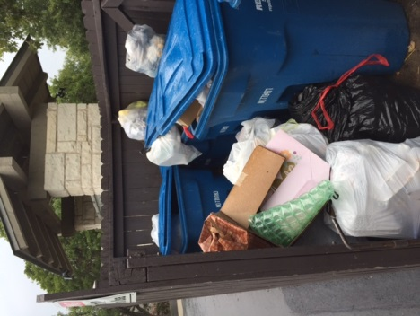 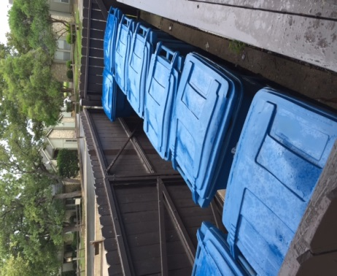 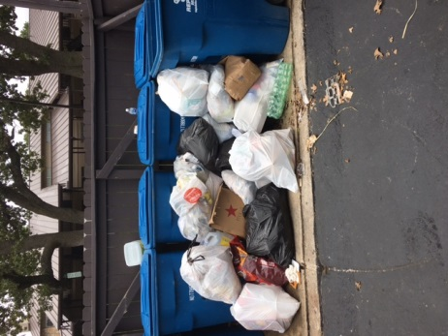

**PETS:**

For your convenience, Bow Wow disposable, plastic bag dispensers have been installed by the trash corrals. Please use these to clean up after your pets. City of Horseshoe Bay codes

(Chapter 2 of City Ordinance Section 2.01.005 Ordinance 08-04-15B Sec II b-adopted 04-15-2005) pertaining to pickup up after your pets and obeying the leash are strictly enforced on our property. Thank you for your cooperation on these issues. City’s Animal Control Officers does patrol our area frequently.

**FEEDING THE DEER:**

In the City of Horseshoe Bay, residents are asked to resist the urge to feed the deer. Feeding them will ultimately cause them distress. It disrupts their natural behavior and encourages them to congregate and lose their natural fear of humans. The best thing you can do is to leave the deer alone. Do not interact with them and enjoy them from a distance. City of HSB has an ordinance, which prohibits the feeding of deer. Any person who violates the provisions of this ordinance commits a Class C Misdemeanor, and is subject to fines from $100 to $500. The Board of The Oaks Condominiums ask for your assistance in this matter. Please do not feed these animals.

On behalf of your Board, we thank you in advance, for your efforts in making The Oaks Condominiums a great place to live. Please feel free to reach us at any time. Enjoy the rest of your summer.

.

“